25-02-2010
George K. Aidoo
SM/SMS/09/0019
Physics Practical

Experiment 6

Measurement of Low Resistance (2)

AIM:

The aim of this experiment is to determine the resistances of three connecting cords of different lengths (36cm, 61cm, and 86cm) by plotting their current/voltage characteristics.

APPARATUS:

Universal measuring amplifier (1), digital multimeter (2), power supply 0-12V DC/6 V, 12 V AC (1), connection box (1), cord of length 100mm yellow (2), cord of length 250mm red and blue (1 each), cord of length 500mm red and blue (2 and 1 respectively), cord of length 750mm yellow and blue (2 and 1 respectively), cord of length 2000mm yellow (2), connecting cords of different lengths; 36cm, 61cm, and 86cm.

PROCEDURE:

Using the connection box, one connection cord (36cm cord), the power supply and the ammeter were connected in series. The input of the amplifier was connected to the sockets of the connecting cord connector, and the voltmeter was then connected to the output of the amplifier, with the voltage source set to 12V. Varying the current at constant intervals of 1.2A, the voltage drop across the cord was measured for each current selected. This was repeated for the 61cm and 86 cm connecting cords.

TABLES OF RESULTS:

Table for the 36cm cord:
Current(I) / A | Voltage / mV
0.20 | 0.56
0.40 | 1.08
0.60 | 1.60
0.80 | 2.12
1.00 | 2.60

Table for the 61cm cord:
Current(I) / A | Voltage / mV
0.20 | 0.90
0.40 | 1.73
0.60 | 2.57
0.80 | 3.39
1.00 | 4.21

Table for the 86cm cord:
Current(I) / A | Voltage / mV
0.20 | 1.47
0.40 | 2.80
0.60 | 4.21
0.80 | 5.57
1.00 | 6.93

Graph of voltage against current for all cords:

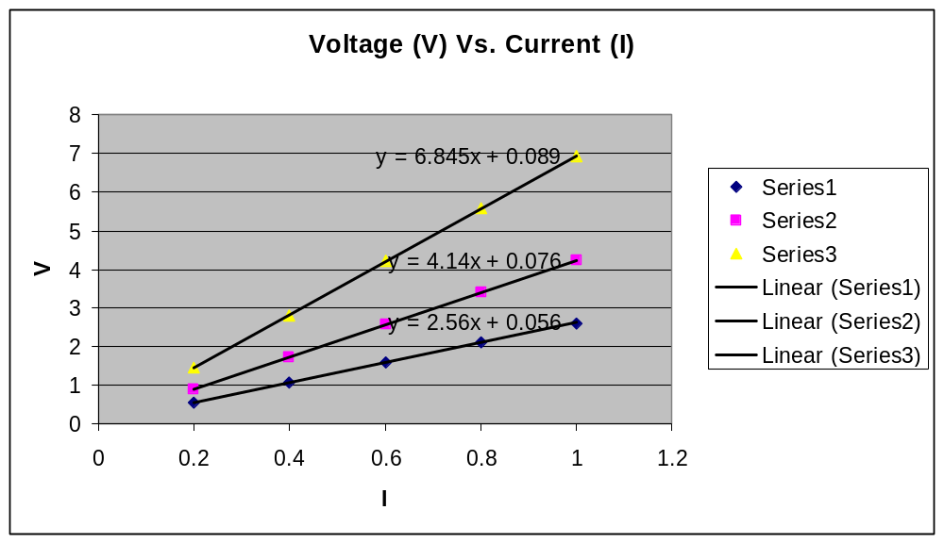

The slope for each line; resistance of each cable used in this experiment is as follows:

Table of cord length and slope:

Slope (resistance) / Ώ | Length of cord / cm
2.56 | 36
4.14 | 61
6.85 | 86

DISCUSSION:

The results of this experiment were concise. As shown above, each cord of different length displayed a different capacity in voltage and current capacity. An interesting observation of the results is the relationship between the length of the cord and its corresponding voltage, and thus resistance, as determined from the slope of each line in the graph. It appears that the length of the cord is directly proportional to the voltage passing through it and its resistance.

SOURCES OF ERROR:

- Errors may have occurred from any undetected malfunction in the cords or apparatus used.
- Parallax errors may have occurred when reading the values of the current ad voltage values.

PRECAUTIONS:

- The cables used in this experiment were protected to avoid electrical shocks.
- The settings on the amplifier and power supply were kept constant to ensure uniform results.

CONCLUSION:

The aim of the experiment to determine the voltage capacities of cords of different lengths and the relationship between these lengths and the slope of the line of each voltage against the corresponding current flowing through it was achieved. The relation ship was determined to be direct proportionality.

REFERENCES:

SERWAY, Raymond A., College Physics/Raymond A. Serway, Jerry S. Faughn, - 6th edition, Pacific Groove, CA 93950. USA. Pg. 412-413

